EXPERIMENT 8

Name: Arav Desai | Roll No: 3
Subject: Programming and problem solving | Class/Batch: AIML A
Date of Performance: 14/8/2024 | Date of Submission:

Code

I. Write a program to add two numbers using function
a. function with return type and with parameters
b. function without return type and with parameters
a.Function with return type and with parameters
#include <stdio.h>

// Function prototype
int add(int a, int b);

int main() {
int num1, num2, sum;

printf("Enter two numbers: ");
scanf("%d %d", &num1, &num2);

// Function call
sum = add(num1, num2);

printf("The sum is: %d\n", sum);

return 0;
}

// Function definition
int add(int a, int b) {
return a + b;
}
b. function without return type and with parameters
#include <stdio.h>

// Function prototype
void add(int a, int b);

int main() {
int num1, num2;

printf("Enter two numbers: ");
scanf("%d %d", &num1, &num2);

// Function call
add(num1, num2);

return 0;
}

// Function definition
void add(int a, int b) {
int sum = a + b;
printf("The sum is: %d\n", sum);
}
Output

- Function with return type and parameter
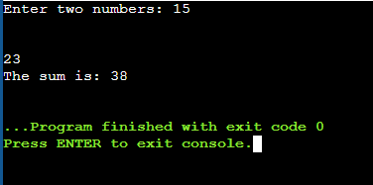
- Function without return type and parameters
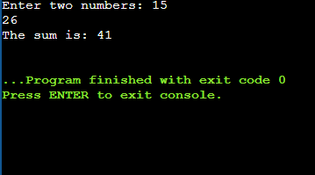
Code
II. Create a function for addition, subtraction and multiplication. Accept two inputs from user and pass as parameter
#include <stdio.h>

int main() {
int n, i, j;

printf("Enter the number of lines: ");
scanf("%d", &n);

for (i = 1; i <= n; i++) {
for (j = 1; j <= i; j++) {
printf("%d", j);
}
printf("\n");
}

return 0;
}

Output
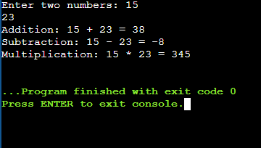

Code

III. Write a program to find the factorial of a number using a function
#include <stdio.h>

// Function prototype
int factorial(int n);

int main() {
int number;

printf("Enter a number: ");
scanf("%d", &number);

// Function call
printf("Factorial of %d is: %d\n", number, factorial(number));

return 0;
}

// Function definition
int factorial(int n) {
if (n == 0) {
return 1;
} else {
return n * factorial(n - 1);
}
}
Output

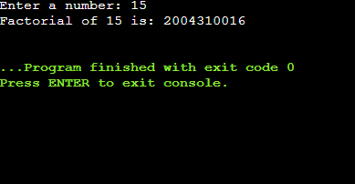

Code

IV. Write a program to find Armstrong number using function
#include <stdio.h>
#include <math.h>

// Function prototype
int isArmstrong(int n);

int main() {
int number;

printf("Enter an integer: ");
scanf("%d", &number);

// Function call
if (isArmstrong(number)) {
printf("%d is an Armstrong number.\n", number);
} else {
printf("%d is not an Armstrong number.\n", number);
}

return 0;
}

// Function definition
int isArmstrong(int n) {
int originalNumber, remainder, result = 0, numDigits = 0;

originalNumber = n;

// Calculate the number of digits
while (originalNumber != 0) {
originalNumber /= 10;
numDigits++;
}

originalNumber = n;

// Calculate the sum of the powers of its digits
while (originalNumber != 0) {
remainder = originalNumber % 10;
result += pow(remainder, numDigits);
originalNumber /= 10;
}

// Check if the result equals the original number
return (result == n);
}

Output

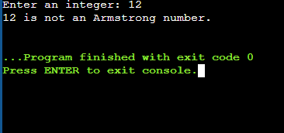

Code
V. Write a program to find the factorial of a number using a RECURSIVE function.
#include <stdio.h>

// Function prototype
int factorial(int n);

int main() {
int number;

printf("Enter a number: ");
scanf("%d", &number);

// Function call
printf("Factorial of %d is: %d\n", number, factorial(number));

return 0;
}

// Recursive function definition
int factorial(int n) {
if (n == 0) {
return 1;
} else {
return n * factorial(n - 1);
}
}
Output
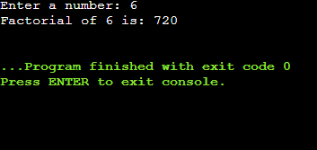

Conclusion

In conclusion, the last five programs we developed highlighted critical programming concepts and practical applications in C. We delved into creating functions with return types and parameters, designing versatile calculator functions, calculating factorials using both iterative and recursive methods, and checking for Armstrong numbers. These exercises reinforced our understanding of function creation, recursion, and efficient code structuring. By tackling these varied problems, we enhanced our problem-solving skills and gained valuable insights into the versatility and power of C programming. This foundation prepares us for more complex challenges ahead, ensuring we're well-equipped for advanced programming endeavors.
Assessment

Timely Submission  (7) | Presentation  (06) | Understanding  (12) | Total  (25) | Sign

